Talking Postpartum Depression Campaign - Sample Newsletter/Blog Verbiage

Use or adjust the information below for your newsletter or blog to help spread the word about the new Talking Postpartum Depression campaign.

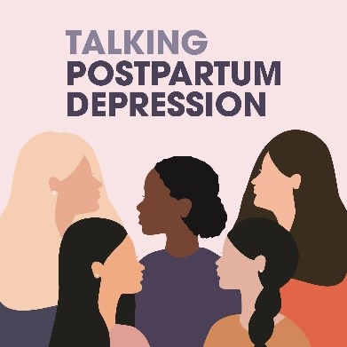
The U.S. Department of Health and Human Services’ (HHS) Office on Women’s Health (OWH) has launched Talking Postpartum Depression: A National Campaign to Decrease Postpartum Depression Stigma and Encourage Women to Seek Help. Postpartum depression (PPD) is a serious mental health condition and public health problem with an estimated 13.4% of U.S. women reporting PPD symptoms in the 12 months after childbirth.

The goal of the Talking Postpartum Depression campaign is to increase self-efficacy of women to seek help for PPD by destigmatizing PPD through increased awareness of PPD symptoms, visibility of reliable resources, and understanding of ways to access care.

The campaign includes ready-to-use resources for women experiencing or at-risk for developing PPD as well as the personal and professional individuals who support them. Campaign resources include video testimonials of women who have experienced and gotten treatment for PPD, downloadable fact sheets, sample social media verbiage, and more.

You can support the campaign and help end the stigma around PPD by:
- Sharing the campaign toolkit materials with your network via email, website, and social media
- Engaging with OWH campaign efforts across social and traditional media
- Encouraging your networks to be part of the campaign and share why you support this cause

To learn more about the campaign, including ways to get involved, visit www.womenshealth.gov/talkingPPD.

